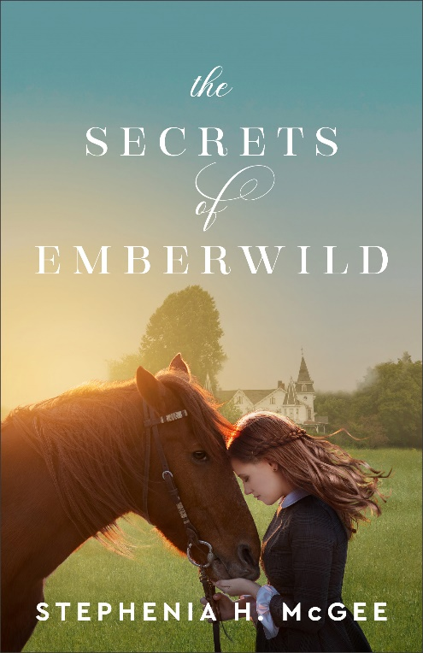
Media Contact:
Karen Steele, Fiction Publicity Manager
(616) 676-9185 ext. 100
ksteele@bakerpublishinggroup.com

One Woman’s Fight for Her Rightful Place

“A spirited woman ahead of her time makes this well-paced novel in an extraordinary setting shine. Rife with suspense and romance, The Secrets of Emberwild is as much history as mystery—and a horse lover’s dream!”
—Laura Frantz, Christy Award–winning author of A Heart Adrift

Ada, Mich.—Award-winning author Stephenia H. McGee brings her southern charm to the forefront in her new tale that fuses together the world of horseracing with past secrets and hidden dangers. Set in the early 1900s, The Secrets of Emberwild, delves into the life of a headstrong woman who is determined to save her struggling horse farm regardless of the obstacles or the people who want to hold her back.
. . . .

Nora Fenton is a gifted trainer in a time when women are not allowed to race. She has come to prefer horses to men. They are easier to handle and more reliable. But when her father passes away, their struggling horse farm is put in jeopardy. To save the farm, she decides to enter her prize colt into the 1905 Mississippi Fair. If she wins, she could gain everything she wishes—stability and independence. The only thing standing in her way is a stranger with disconcerting questions and the potential to take what is rightfully hers.

Silas Cavallero wants answers to the mysteries surrounding his father’s death. To unearth what is hidden, he has to battle Nora’s desire for him to disappear as well as the whims of an unwieldy colt. But there is someone who would rather the truth remain buried. Is learning the secrets of his own past worth risking a future with the woman he’s come to admire?

Join Stephenia H. McGee in a captivating tale of mystery, history and love in The Secrets of Emberwild.

About the Author

Stephenia H McGee is the award-winning author of many stories of faith, hope, and healing set in the Deep South. When she's not reading or sipping sweet tea on the front porch, she's a writer, dreamer, husband spoiler, and busy mom of two rambunctious boys. Learn more at www.stepheniamcgee.com.

__________________________________________________________

PRAISE for The Secrets of Emberwild
“Saddle up for a ride you won’t want to end. This story of secrets and second chances is full of everything I love: fully developed characters, a well-drawn plot, and a pace that’s just right, whether it’s trotting through unfolding revelations or galloping through the climax to the end. Stephenia H. McGee writes with both authority and heart. She’s an author I trust for historical integrity and a captivating tale every time.”
—Jocelyn Green, Christy Award–winning author of Drawn by the Current
“Stephenia H. McGee is a master at writing Southern charm and historic detail, and she’s outdone herself with The Secrets of Emberwild. This fascinating story draws you in with characters who come alive from their first step onto the page. McGee’s clear knowledge of horsemanship shines throughout. This is one for the keeper shelf!”
—Misty M. Beller, USA Today bestselling author of the Brides of Laurent series
“In her book The Secrets of Emberwild, Stephenia H. McGee will enchant readers as they discover a bygone era filled with mystery, romance, and realistic characters. Her masterful ability at creating stories will have readers searching out her books for years to come.”
—Dawn Crandall, award-winning author of The Hesitant Heiress and The Everstone

The Secrets of Emberwild
by Stephenia H McGee
. . . . .

Paperback ISBN: 978-0-8007-4023-8
$16.99; 352 pp
Release date: October 2022

Get Connected:

Stephenia H McGee
www.StepheniaMcGee.com

@StepheniaHMcGee

@StepheniaHMcGee

@stepheniahmcgee

Sample Interview Questions for Stephenia H. McGee
The Secrets of Emberwild

- Can you please provide a brief summary of your novel, The Secrets of Emberwild?
- Your character Nora Fenton is a talented horse trainer. Why did you choose this profession for your protagonist?
- Nora struggles to be accepted as a legitimate trainer because of her gender. What drew you to exploring this theme?
- Your novel is set in Mississippi in the early 1900s. Whey did you choose this setting?
- Did any of your personal experiences influence your writing of The Secrets of Emberwild?
- What do you hope readers will gain from reading your novel?
- Do you identify with any of your characters in particular?
- What do you love about writing about the deep south?
- Are readers always promised a “happily ever after” in your novels?
- What are you working on next?
- How can readers connect with you?

GUEST: Stephenia H. McGee, author

BOOK: The Secrets of Emberwild (available October 2022, Revell)

