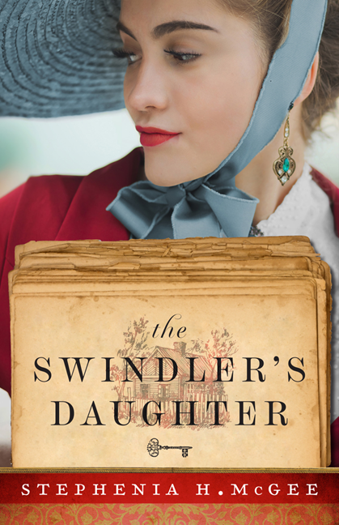
wit
Media Contact:
Karen Steele, Fiction Publicity Manager
(616) 676-9185 ext. 100
ksteele@bakerpublishinggroup.com

Award-Winning Novelist Incorporates Southern Charm into her Narrative of Discovery and Family
“The Swindler’s Daughter is a compelling story with characters I enjoyed getting to know as they faced challenges in times of uncertainty in their lives. If you like stories of romance, mystery, and action set in realistic historical times and places, you won’t want to miss this book.”
—Ann H. Gabhart, bestselling author of When the Meadow Blooms

Ada, Mich.—Stephenia H. McGee combines history, intrigue, and romance in her new novel, The Swindler’s Daughter. Set in the Deep South, this captivating tale follows the path of an aristocratic young woman as she copes with life-changing circumstances and discovers a family she never knew existed.
. . . .

A high society lady, Lillian Doyle has only her widowed mother for family, believing her father died many years before. But her world is completely changed when she receives the news that her father has only just passed—in jail. Not only is Lillian shocked by this news, she also learns she is the heiress to all of her father’s earthly possessions including a run-down house and a business.

As Lillian travels to rural Georgia to take possession of her “new” home, she soon learns there is one small catch—a woman is already living in the house and she insists that it belongs to her son, Jonah. The inherited business is also more than meets the eye and has put her into a treacherous situation.

But Lillian isn’t ready to give up on her strange inheritance. With the danger comes the possibility of truth and independence, and she is determined to have both. To do that, she’ll have to turn her enemies into allies, including Jonah, an unrefined cowboy who has secret aspirations of his own.

About the Author

Stephenia H. McGee is the award-winning author of many stories of faith, hope, and healing set in the Deep South, including The Secrets of Emberwild. When she's not reading or sipping sweet tea on the front porch, she's a writer, dreamer, husband spoiler, and busy mom of two rambunctious boys. Learn more at www.stepheniamcgee.com.

__________________________________________________________

PRAISE for The Secrets of Emberwild

“Christians will appreciate the conclusion’s upbeat message. This charming story has lots to like.”
—Publishers Weekly
“This is a great pick for readers who like historical fiction and cozy mysteries with a strong female lead. Hand to fans of Carrie Turansky and Laura Frantz.”
—Library Journal
“McGee, with her well-paced writing, interesting characters, and historical detail, spins a delightful story of a woman’s battle for independence and a man’s search for the truth. Compelling and engaging, with characters to root for.”
—The Historical Novels Review
“Well-developed and memorable characters, an expertly crafted plot filled with mystery and emotion, a gentle and inspiring faith thread, a bit of sweet romance, and extensively researched historical detail are skillfully woven together to make this a captivating, satisfying read.”
—Interviews and Reviews

The Swindler’s Daughter
by Stephenia H. McGee
. . . . .

Paperback ISBN: 978-0-8007-4024-5
$15.99; 352 pp
Ebook ISBN: 978-1-4934-4136-5
Release date: May 2023

Get Connected:

Stephenia H. McGee
www.stepheniamcgee.com

@ StepheniaHMcGee

@ stepheniahmcgee

@ stepheniaHMcGee

Sample Interview Questions for Stephenia H. McGee
The Swindler’s Daughter

- Can you please provide a brief summary of your new novel, The Swindler’s Daughter?
The Swindler’s Daughter is about a young woman who spent her entire life believing she was a widow’s daughter. When she discovers that her father has instead recently passed—in jail—Lillian’s carefully ordered world begins to unravel. She travels to a backwoods Georgia town to settle her father’s estate, only to discover she’s become a rather unusual heiress.
- The Swindler’s Daughter offers a complicated family story. What was the inspiration for your novel?
Family can be complicated. There is the family we are born from, those who raise us, and those we choose to love. The people closest to us can at times cause both the greatest joys and greatest frustrations in our lives. In this book, I wanted to highlight family ties and complicated relationships and show how learning the truth and the stories of the past can shape how we see the future.
- Your two main characters, Lillian and Jonah, are very different. What ties the two of them together?
They are very different! Lillian was brought up by a very strict mother whose chief goal was to further their social standing and station in life. Jonah became the primary provider for his mother and sisters at a young age, and he is a hard-working man who values family. But underneath all of their differences, they share a common faith, a love for chasing dreams, and a desire to belong.
- Both The Swindler’s Daughter and your previous novel, The Secrets of Emberwild, feature women who desire independence. What inspires you to write about empowered women?
I love strong heroines. Strength comes in many facets, and where Nora from The Secrets of Emberwild was fierce and opinionated, Lillian is quietly firm. She takes each challenge as it comes and faces it with steel in her spine. I’m inspired by women like that, having been raised by a mother who portrayed courage, determination, and strength of character to me each day.
- What type of research was required to accurately portray the setting and time period for The Swindler’s Daughter?
This one required a lot of research. I can’t give away too much about what kind of business Lillian’s father was into, but I did end up buying seven different research books on the subject as well as spending hours in online research. On top of that, this is the first novel I’ve written this deep into the nineteen hundreds at a time when technology is just starting to pick up steam. I had to research everything from automobiles to what kind of stoves and refrigerators they would have.
- What do you hope readers will gain from reading The Swindler’s Daughter?
This is a story of family, faith, and discovering your purpose. Lillian struggles with reconciling all of her own plans and expectations for her life with the wild, adventurous, and rather surprising plan God seems to have instead. I hope readers will see a little of themselves in her and explore some of these same themes about God’s perfect—if sometimes not at all what we expected—plans for our lives.
- What do you love most about writing historical fiction?
I really enjoy the research and imagining what it might be like to live in those times. The fashion and style of the early 1900s was classy and there was a sense of new beginnings stirring at the turn of the century. I enjoy immersing myself in those simpler times before televisions and cell phones and creating a story deeply set in the richness of history.
- What are you working on next?
I just finished writing a new novel about a showboat set on the Mississippi River in 1923. There’s glitz and glam, a close-knit quirky family, and a quiet accountant whose entire world changes when he encounters the fiery young singer who rules The River Queen.
- How can readers connect with you?
I love talking to readers! You can find out more about me on my website, StepheniaMcGee.com, and you can connect with me anytime on Facebook and Instagram.
Facebook: Stephenia H. McGee, Christian Fiction Author
Instagram: StepheniaHMcGee
- Where can readers purchase a copy of The Swindler’s Daughter?
The best place to get paperback copies is from Baker Book House. They offer some pretty amazing discounts (and free shipping!) on pre-orders and new releases.
https://bakerbookhouse.com/products/492093
You can also purchase paperbacks and eBooks from your favorite bookstore including Amazon, Barnes and Noble, and Christian Book.

GUEST: Stephenia H. McGee, author

BOOK: The Swindler’s Daughter (available May 2023, Revell)

